GESŠ Trbovlje
Gimnazijska 10
1420 Trbovlje

Marilyn Monroe

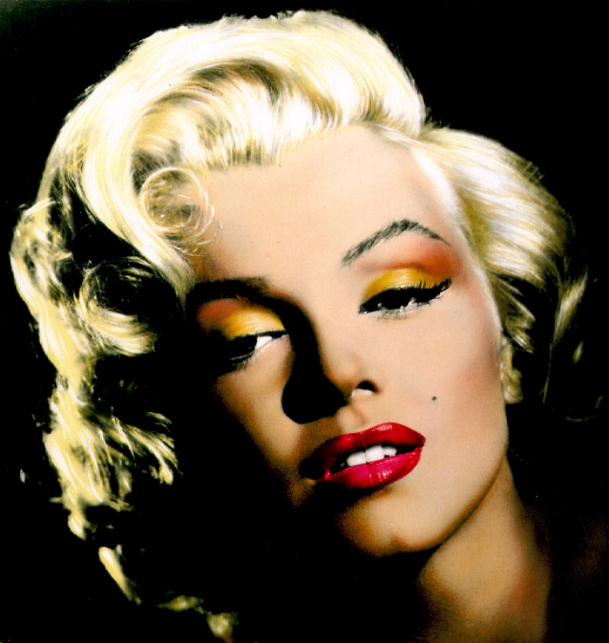

Author: dijak Mentor: prof

Trbovlje, november 2005
Biography
Marilyn Monroe personified Hollywood glamour with an unparalleled glow and energy that enamoured the world. Although she was an alluring beauty with voluptuous curves and a generous pout, Marilyn was more than a '50s sex goddess. She dominated the age of movie stars to become, without question, the most famous woman of the 20th Century.
She was born Norma Jeane Mortenson on June 1, 1926 in Los Angeles, California, to Gladys Baker. As the identity of her father is undetermined, she was later baptized Norma Jeane Baker. Gladys had been a film cutter at RKO studios, but psychological problems prevented her from keeping the job and she was eventually committed to a mental institution.
Norma Jeane spent most of her childhood in foster homes. On June 19, 1942 she wed her 21-year-old neighbour Jimmy Dougherty, whom she had been dating for six months. By all accounts Norma Jeane loved Jimmy, and they were happy together until he joined the Merchant Marines and was sent to the South Pacific in 1944.

After Jimmy left, Norma Jeane took a job on the assembly line at the Radio Plane Munitions factory in Burbank, California. Several months later, photographer David Conover saw her while taking pictures of women contributing to the war effort for Yank magazine. She was a "photographer's dream." Conover used her for the shoot and then began sending modelling jobs her way. The camera loved Norma Jeane, and within two years she was a reputable model with many popular magazine covers to her credit.
Norma Jeane divorced Jimmy in June of 1946, and signed her first studio contract with Twentieth Century Fox on August 26, 1946. She earned $125 a week. Soon after, Norma Jeane dyed her hair blonde and changed her name to Marilyn Monroe (borrowing her grandmother's last name). The rest, as the saying goes, is history.
Marilyn's first movie role was a bit part in 1947's The Shocking Miss Pilgrim. From then on Marilyn worked steadily in movies such as: Let's Make It Legal, As Young As You Feel, Monkey Business and Don't Bother to Knock. It was her performance in 1953's Niagara, however, that delivered her to stardom. Marilyn played Rose Loomis, a beautiful young wife who plots to kill her older, jealous husband (Joseph Cotten). Photoplay magazine voted Marilyn the Best New Actress of 1953, and at 27 years old she was undeniably the best-loved blonde bombshell in Hollywood.
On January 14, 1954, Marilyn married baseball superstar Joe DiMaggio at San Francisco's City Hall. They had been a couple for two years, after Joe asked his agent to arrange a dinner date. Unfortunately, Marilyn's fame and sexual image became a theme that haunted their marriage. Nine months later on October 27, 1954, Marilyn and Joe divorced. They remained close friends.
Marilyn was ready to shed her "shallow blonde" image by 1955. It had gotten her into the spotlight, but now that she had the opportunity and experience, Marilyn wanted to pursue serious acting. In 1956, Marilyn started her own motion picture company, Marilyn Monroe Productions. Marilyn received further recognition for 1959's Some Like It Hot, winning a Golden Globe for Best Actress in a Comedy.

On June 29, 1956, Marilyn wed playwright Arthur Miller. While they were married, Arthur wrote the part of Roslyn Taber in 1961's The Misfits especially for Marilyn. Sadly, the marriage between Marilyn and Arthur ended on January 20, 1961, and The Misfits was to be Marilyn's (and Gable's) last completed film. At the 1962 Golden Globes, Marilyn was named female World Film Favorite.
Sadly, in a shocking turn of events on the early morning of August 5, 1962, 36-year-old Marilyn died in her sleep at her Brentwood, California home. The world was stunned. Marilyn's vibrant spirit and beauty made it impossible to believe she was gone. On August 8, 1962, Marilyn's body was laid to rest in the Corridor of Memories, #24, at Westwood Memorial Park in Los Angeles, California.
During her career, Marilyn made 30 films and left one, Something's Got to Give, unfinished. She was more than just a movie star or glamour queen. A global sensation in her lifetime, Marilyn's popularity has extended beyond star status to icon.

Today, the name "Marilyn Monroe" is synonymous with beauty, sensuality and effervescence. She remains an inspiration to all who strive to overcome personal obstacles for the goal of achieving greatness.

Fast Facts

Birth Name: Norma Jeane Mortenson
Also Known As: Norma Jeane Baker
Birth date: June 1, 1926
Birth place: Los Angeles, CA
Death date: August 5, 1962
Death place: Brentwood, CA
Burial location: Corridor of Memories, #24, at Westwood Memorial Park in Los Angeles, CA
Height: 5 feet 5 1/2 inches
Weight: Varied, 115 - 120 lbs.
Writing hand: Left
Measurements: 37-23-36 (Studio's Claim); 35-22-35 (Dressmaker's Claim)
Hair color: Blond
Eyes: Blue
High schools: Van Nuys High School; University High School
Occupations: Model, Actress, Singer
Mother: Gladys Baker
Half-brother: Hermitt Jack Baker
Half-sister: Berniece Miracle
Marriages: Jimmy Dougherty (1942-1946); Joe DiMaggio (1954); Arthur Miller (1956-1961)
Stepchildren: Joe DiMaggio, Jr., Jane and Robert Miller
Did you know?
In 1999, Marilyn was named the Number One Sex Star of the 20th Century by Playboy magazine
In 1999, Marilyn was voted the 'Sexiest Woman of the Century' by People Magazine.
Issued on June 1, 1995, Marilyn was featured on a 32¢ US commemorative postage stamp.
In December 1953, she was the Playboy "Sweetheart" of the Month.
In February 1953, Marilyn was named the “The Most Advertised Girl in the World” by the Advertising Association of the West.

